Quiz 3 Study Guide
MKTG 310
Professor Towns – Fall 2025

This study guide is meant to serve as a general guide and outline of topics and general information about the quiz. It is NOT intended to be a comprehensive list of quiz content.
Quiz Goal:
The quiz is primarily designed to make sure that you are keeping up with the reading and attending/paying attention in class. It will check your knowledge of basic concepts from the book and from lectures/in-class discussion. There is plenty of content in the chapters that we are not able to specifically discuss in class that you are still responsible for, but you are more likely to see content that is in the text AND was discussed in class. Later quizzes will include more application than this first one.
Quiz Format:
The quiz will be pen/paper (you bring the pen, I’ll provide the paper) in-class and will be closed book/closed note. No cell phone or smart watch use is permitted. You may not leave the classroom and return once the quiz has been handed out so please plan restroom and water access accordingly. Please make sure your writing is legible.
The format will be mostly multiple choice with some short answer, fill in the blank and true/false. It will not be long and will be easily finished within the class period but you are welcome to stay and take the entire class time – I’ll be here. Once you have finished the quiz you are free to go – we will not have additional lecture that day.
Model of Consumer Behavior
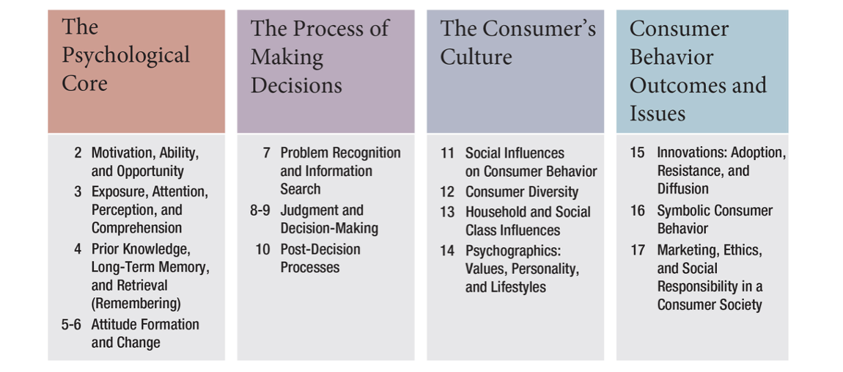

The last two segments of the course will be covered in this quiz. Spanning the textbook chapters 11-17 we have focused so far on the Consumer’s Culture and Outcomes/Issues, which includes topics like:
- Social Influences on Consumer Behavior
- Consumer Diversity
- Psychographics, values, personality, lifestyle
- Innovation, Adoption, Resistance

Be familiar with the following concepts:

Understand the sources of influence (Marketers, nonmarketing sources) and types of influence
Know what Generational Cohort Theory is and what the common cohorts are
Be familiar with how ethnic and religious differences affect Consumer Behavior
Be familiar with types of households
Understand Values and the role that they play in consumer behavior
Be familiar with Innovations – what they are, how they are characterized
Know adopter groups and their characteristics, profile
Know what Diffusion is and be familiar with diffusion curves
Know characteristics surrounding innovation, adoption, resistance and diffusion
Be familiar with Role Acquisition
Understand what Special Possessions are and examples of types
Be familiar with examples of consumption controversies
Be familiar with Social Responsibility issues in marketing

